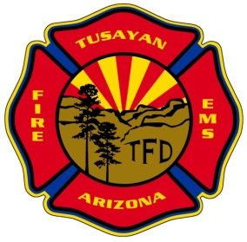P.O. Box 3625

Grand Canyon, AZ 86023

928-638-3473 – Phone

**Tusayan Fire District**

**MINUTES OF MONTHLY PUBLIC MEETING FOR THE TUSAYAN FIRE DISTRICT BOARD OF DIRECTORS**

A public meeting of the Tusayan Fire District Governing Board was convened on, August 22, 2024 at the Tusayan Fire Station and via Zoom conference call, Tusayan AZ 86023.

**Call to Public/Confirmation of Quorum**

Meeting was called to order at 10:02 a.m. The following members of the Tusayan Fire District were present in person, Board Chair John Vail, Board Member Andrew Aldaz, Board Member Peter Shearer (via phone). Others in attendance included Fire Chief Greg Brush, Chief of Administration Kate Johnson, Administrative Assistant Leattea McCarthy, quorum was confirmed.

**Discussion/Approval of July 11, 2024 Regular Meeting Minutes**

Discussion tabled.

**Financial Report**

Discussion tabled.

**Fire Chiefs Update**

Discussion tabled.

**Old Business**

**Discussion, Update, and Possible Action Regarding Community Evacuation Plan**

Discussion tabled.

**Discussion and Possible Action and Approval regarding Town or Tusayan IGA**

Board Chair, John Vail & Fire Chief, Greg Brush signed Tusayan IGA.

**Discussion, Update, and Possible Action Regarding Agreement with the Forest Service to build an enclosed, heated parking bay structure**

Discussion tabled.

**New Business**

Discussion, Possible Action, and Approval Regarding Legal Representation for FY 2024-2025

Resolution 2024-04 Legal Representation.

Board Chair John Vail made the motion to approve the resolution, seconded by Andrew Aldaz. Motion passed unanimously.

**Board Member Reports**

Aldaz – Discussion tabled.

Shearer – Discussion tabled.

Vail – Discussion tabled.

**Adjourn**

Meeting adjourned at 10:06 a.m. First by Vail, seconded by Aldaz. Motion passes unanimously.

**Minutes approved by Board on Date __________________________________________________ _____**

**By _______________________________________________________________________________________**

"To ensure compliance with Open Meeting Law, recipients of this message should not forward it to other board members or anyone. Board members may reply to this message, but they should not send a copy of the reply to other members."